**DEEP2NEURON TECH ACADEMY-INTERNSHIP 2023**

**DAY 3 -21.06.2023**

On the third day, a multi class dataset was given named as exam dataset and was asked to execute in google colab. I uploaded the entire folder in my drive. It took huge time as the folder contains 4000+ files.

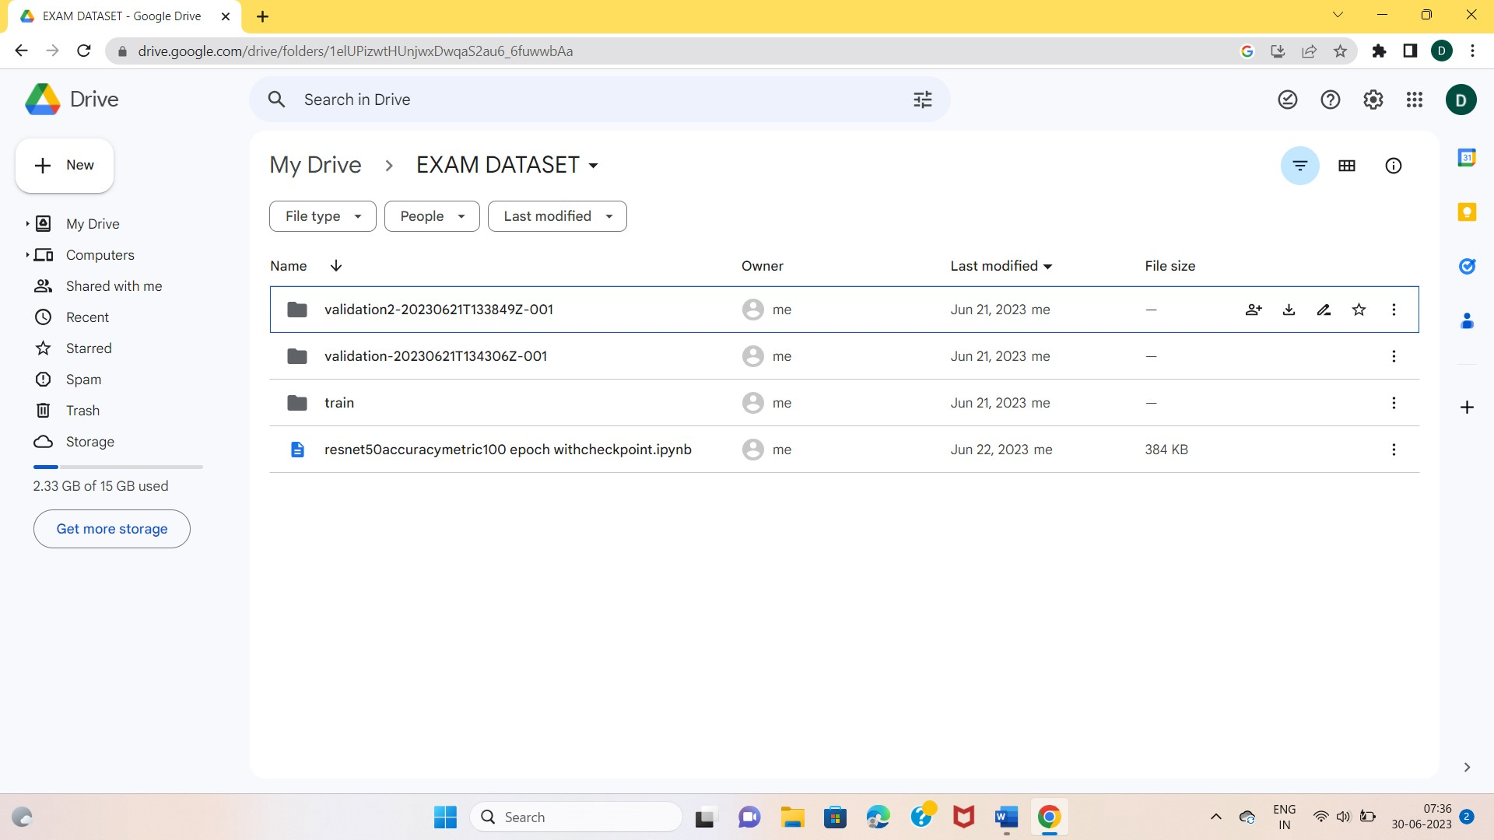

**ACTIVITIES :**

I mounted my drive in the google colab and started executing the code . At the beginning, it was same as the previous day I followed the steps properly and got the output easily by making minor changes in my code. I faced some difficulty in plotting the confusion matrix. The output didn’t come efficiently and I had no idea on how to plot the matrix. I referred and learnt in net about its structure and how it was constructed still I couldn’t get a clear picture about it. Then, I worked on my code and got the matrix.

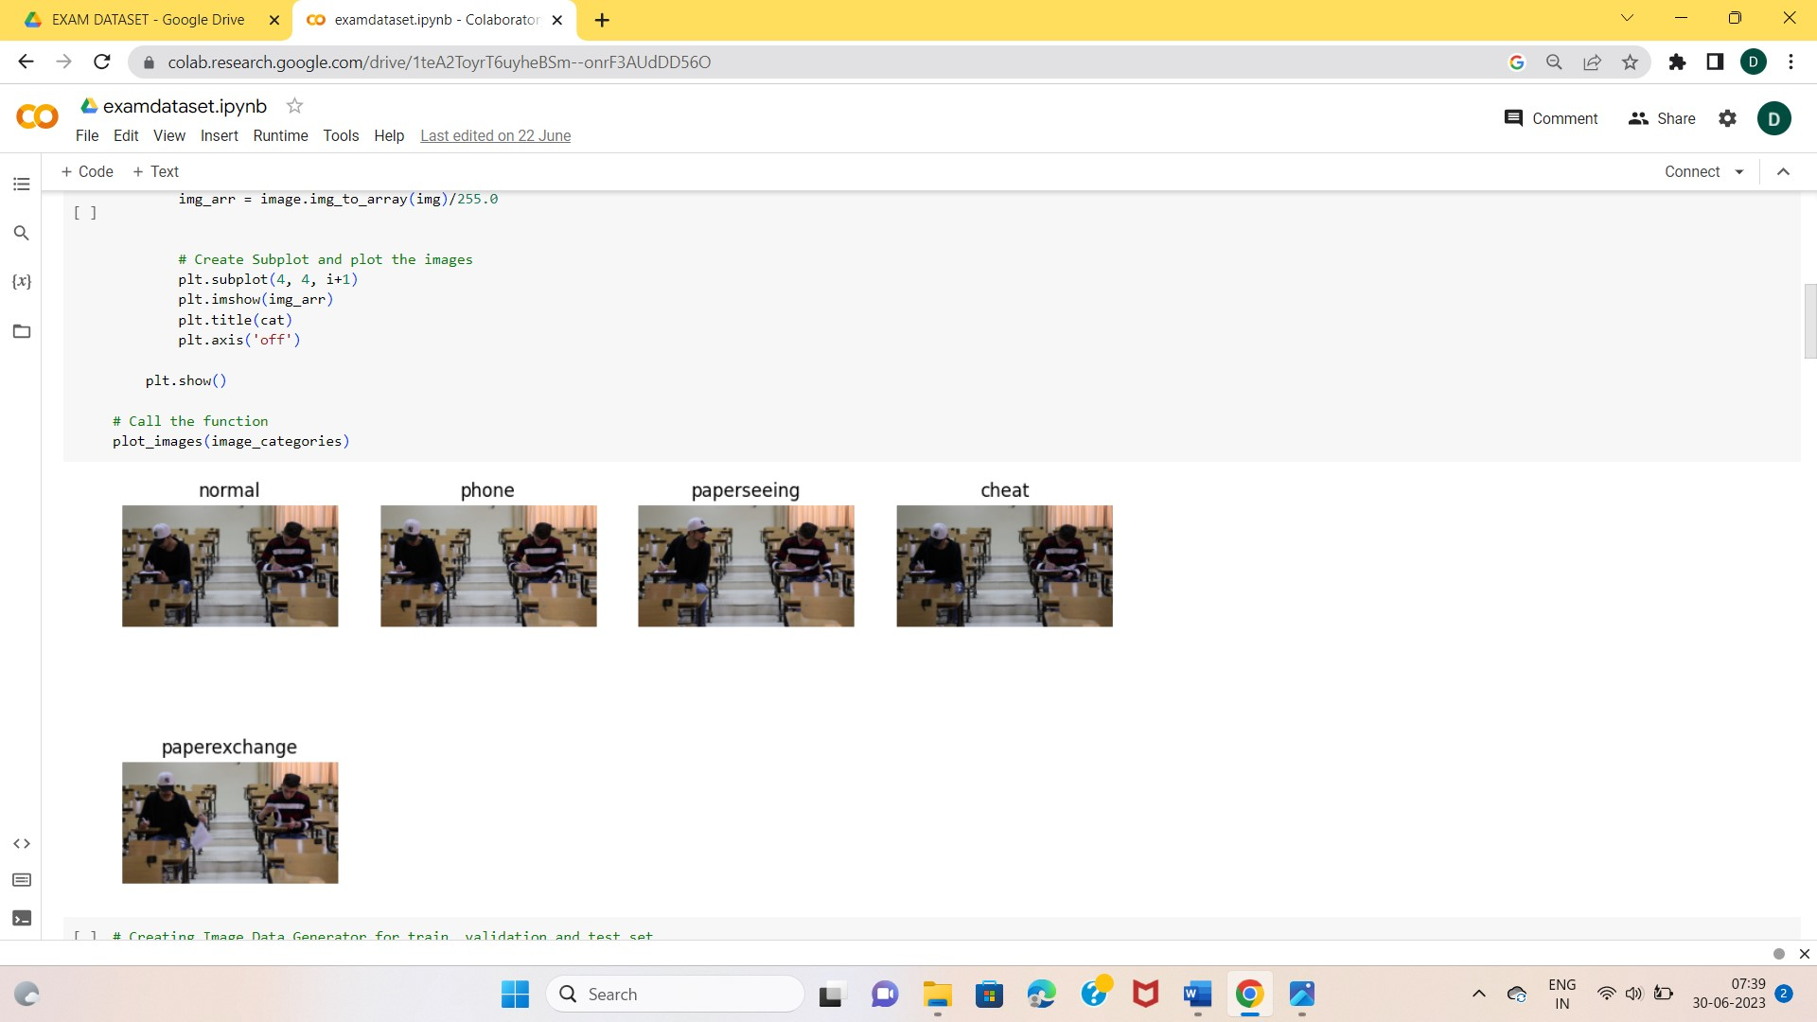

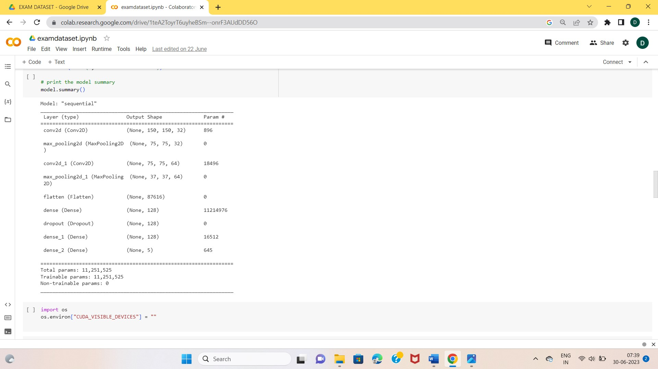

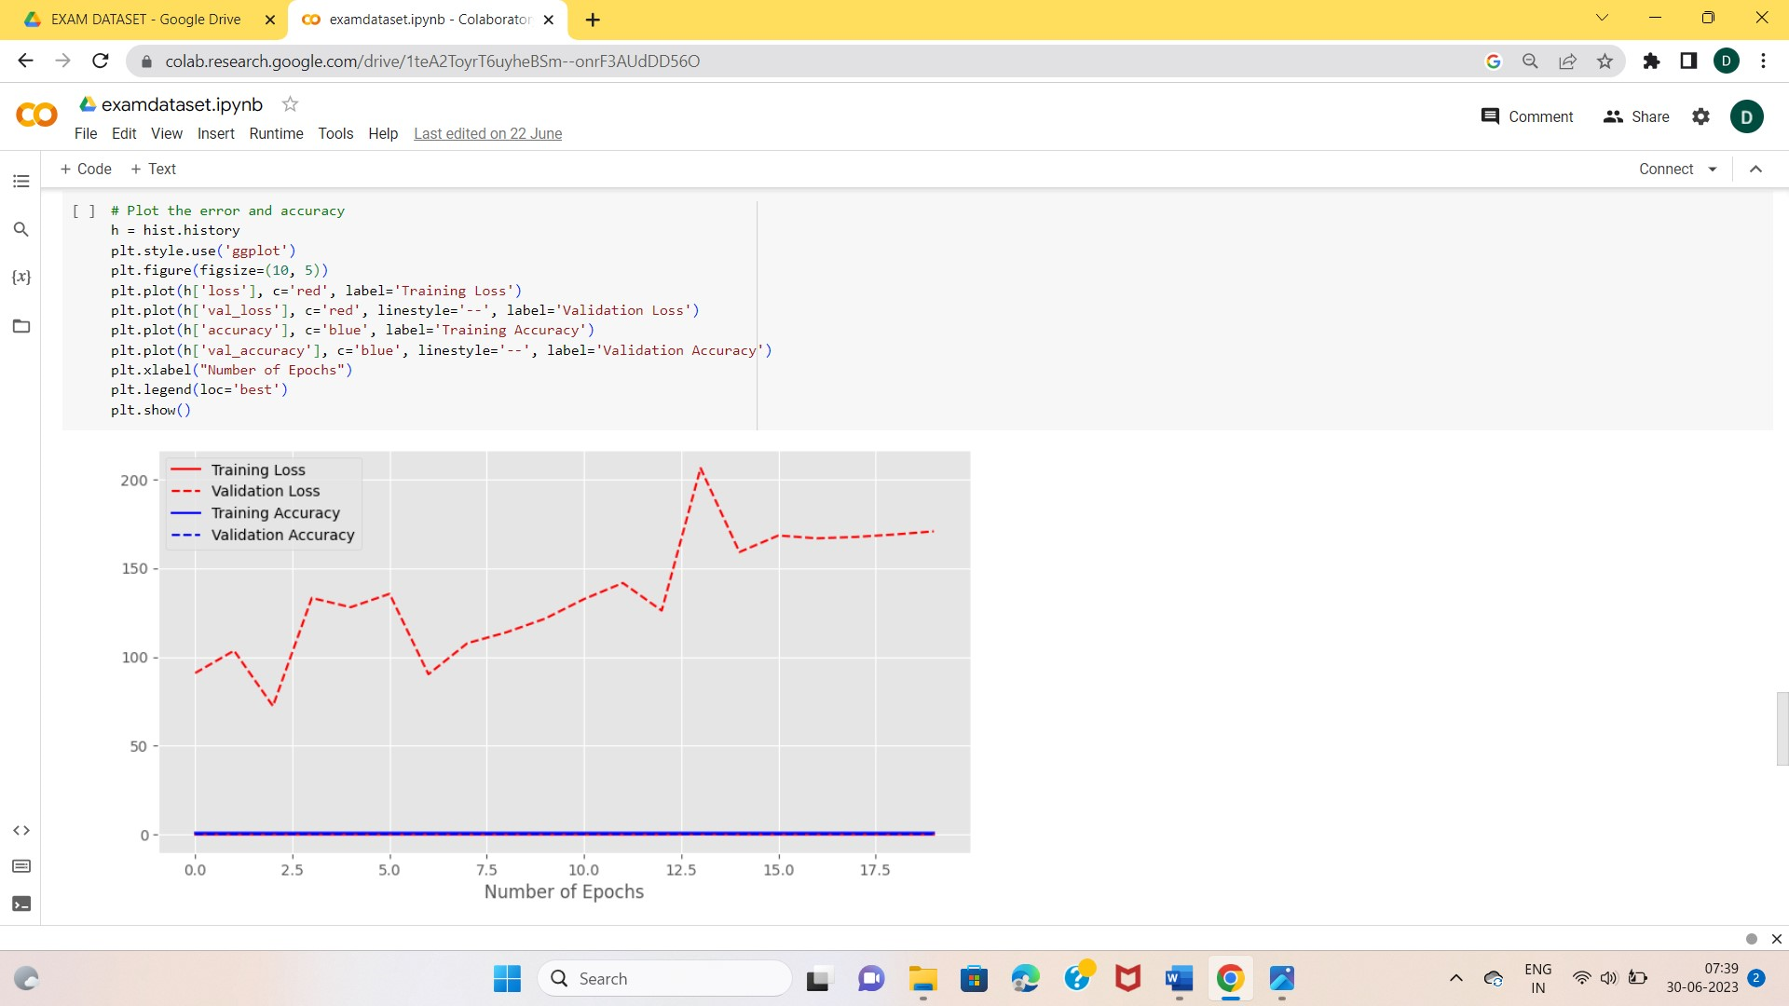 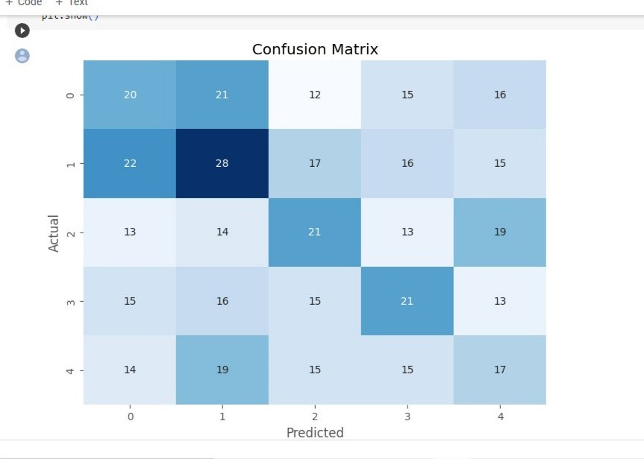

**DOUBTS :**

* No idea on how confusion matrix is built.
* Purpose of epochs in code.